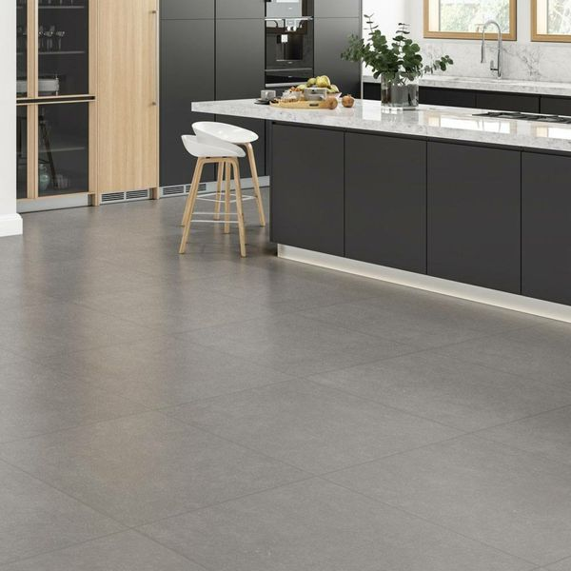

Karlon Ash Grey Tiles: <https://www.wallsandfloors.co.uk/karlon-ash-grey-tiles>

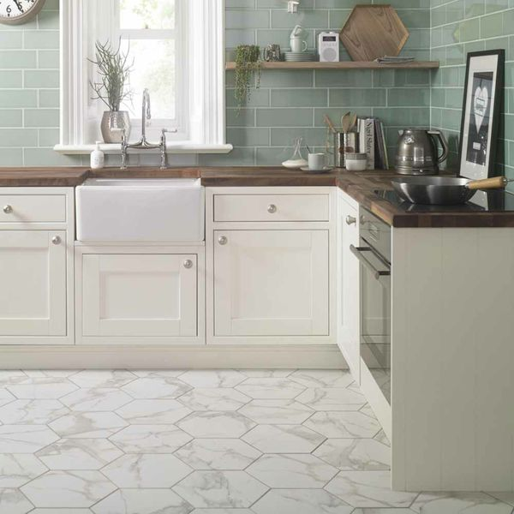

Voronoi White Marble Effect Hexagon Tiles: <https://www.wallsandfloors.co.uk/voronoi-marble-effect-hexagon-tiles-anais-white-hexagon-tiles>

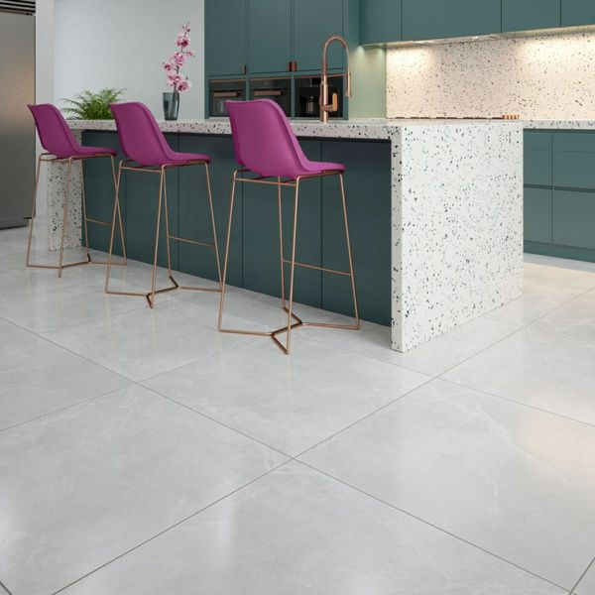

Stonemood White Tiles: <https://www.wallsandfloors.co.uk/stonemood-white-tiles>

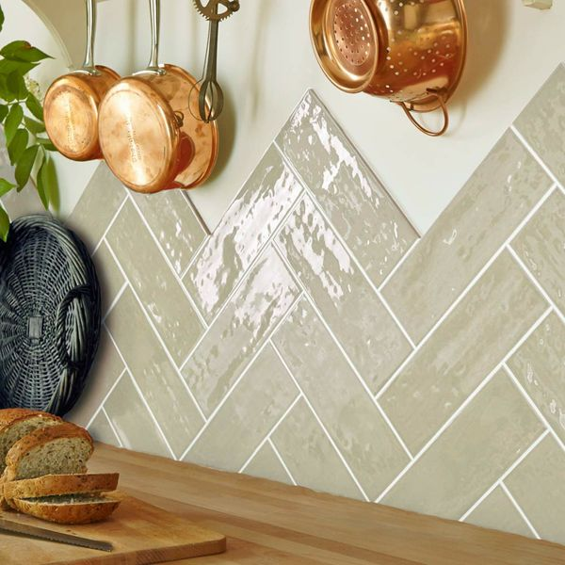

Almond Rustic Metro Tiles: <https://www.wallsandfloors.co.uk/rustic-metro-300x100-almond-gloss-tiles>

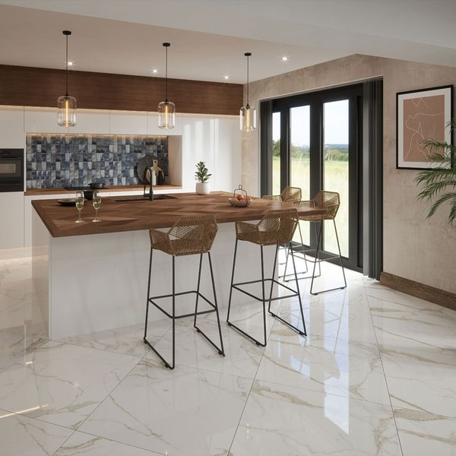

Ruscello Gold Gloss Marble Effect Tiles: <https://www.wallsandfloors.co.uk/ruscello-gold-gloss-60x60-marble-effect-tiles>

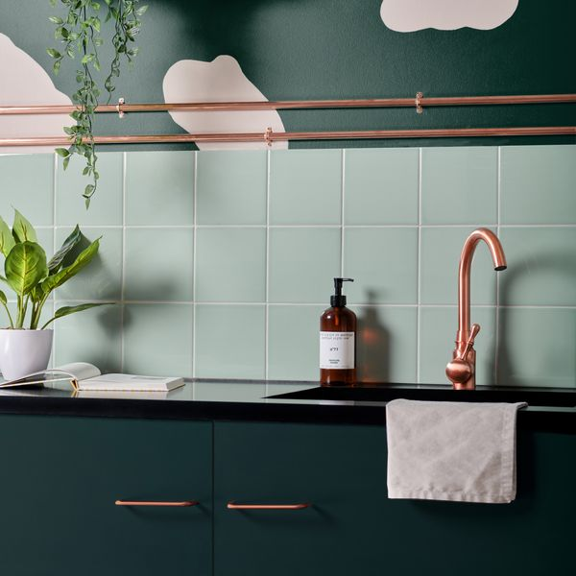

Pistachio Pick n’ Mix Gloss Tiles: <https://www.wallsandfloors.co.uk/pistachio-pick-n-mix-gloss-tiles>